Project Development Phase Performance Test
Date | 04 July 2026
Team ID | SWTID-2026-4563
Project Name | Visualizing Housing Market Trends: An  Analysis of Sales Price and Features Using Tableau
Maximum Marks | 5 Marks

Model Performance Testing:
Project team shall fill the following information in model performance testing template.

S.No. | Parameter | 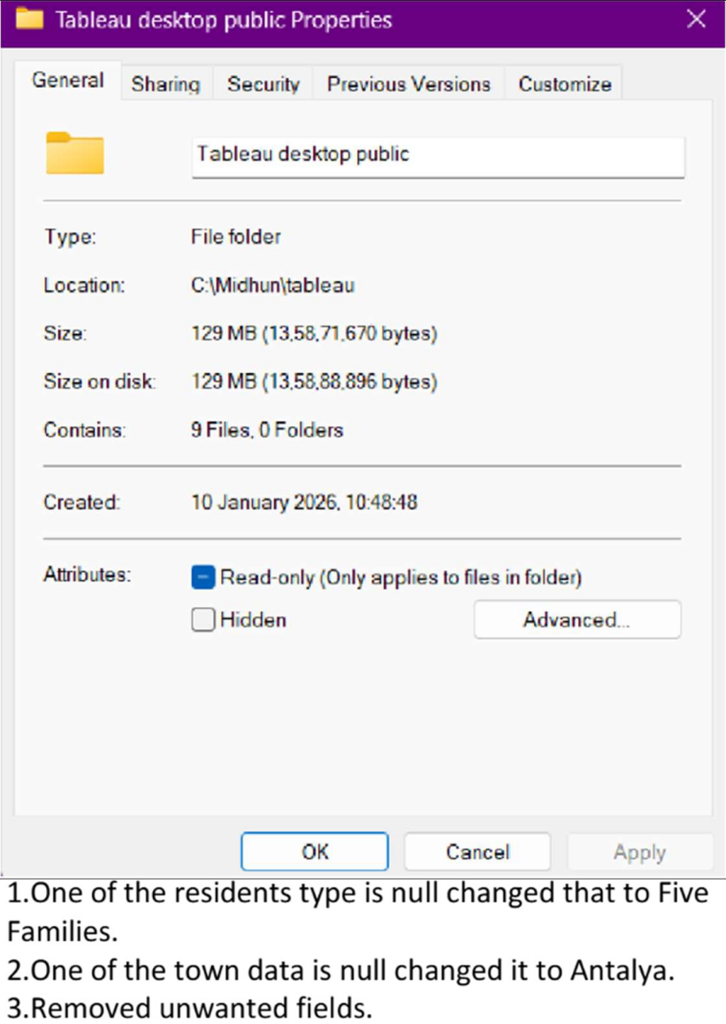  Screenshot / Values
1. | Data Rendered
2. | Data Preprocessing
3. | Utilization of Filters | List Years, Resident Type, Property Type

4. | Calculation fields Used | -----
5. | Dashboard design
6 | Story Design | 